Slide 1
Coronary Heart Disease
By Jim Brendlinger

Slide 2
Coronary Heart Disease or CHD, is the blockage of critical arteries that lead to the heart. The blockage is caused by a process known as atherosclerosis, or the hardening of arteries. It’s the buildup of cholesterol and fatty deposits which impede the blood flow to the heart.
Slide 2
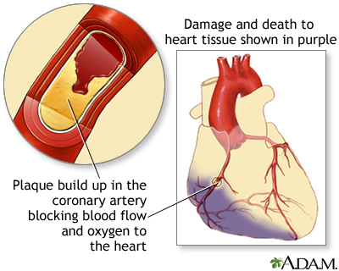
Slide 3
Causes include lack of exercise, poor diet, and genetics.
There are a number of ways to diagnose the illness, including having your blood pressure checked, taking a blood test or cholesterol test. There are also other tests which include an electrocardiogram, x-rays-echocardiogram, coronary angiography, radionuclide tests, and magnetic resonance imaging.
Slide 4
There are a few ways to treat CHD, there are several medications which main function is to thin the blood and decrease the amount of bad cholesterol.
There is also a surgical option, which includes a coronary artery bypass or in more severe cases a heart transplant. Non-surgical options include coronary angioplasty.
Slide 5
Prevention measures comes down to making lifestyle changes. Maintaining your weight, eating a healthy diet, smoking cessation, especially avoiding trans fats, and always exercising. Increased stress can also contribute to CHD.
Slide 6
The controllable risk factors include diet and exercise, uncontrollable risk factors include your genealogy and the environment.
Slide 7
During recovery it’s important to practice self-care. It’s important to make those important lifestyle changes a part of your daily life.
Slide 8
As a part of prevention, it’s also important if you have diabetes to keep your diabetes under control. It’s also recommended to take any medication that are prescribed to you.

- The role the immune system plays in prevention or recovery from this disease
- Reliable community and web resources for individuals with the disease
- Guidelines for making wise health care decisions about treatment and prevention of this disease
- Information on complimentary and alternative health care options for individuals with this chronic disease
- A reference slide with a minimum of three references

http://www.nhs.uk/Conditions/Coronary-heart-disease/Pages/Diagnosis.aspx

http://www.ncbi.nlm.nih.gov/pubmedhealth/PMH0004449/

